Dashboard Summary: AgriCast360

This is my 'AgriCast360' dashboard. I designed it to provide a complete 360-degree view of the agricultural commodity market. In it, I've integrated executive-level KPIs, detailed commodity price analysis, market intelligence, weather impact correlations, and predictive analytics. For some of the more complex calculations and data modeling, I used Google Gemini for code building assistance.

To build this, I analyzed 14.97K records across 68 commodities and 19 markets, and I calculated the average price to be ₹4.51K.

📊 Page 1: Executive Overview

🌾 Page 2: Commodity Analysis

📍 Page 3: Market Intelligence

☀️ Page 4: Weather Impact

📈 Page 5: Predictive Analytics

❓ Dashboard Q&A

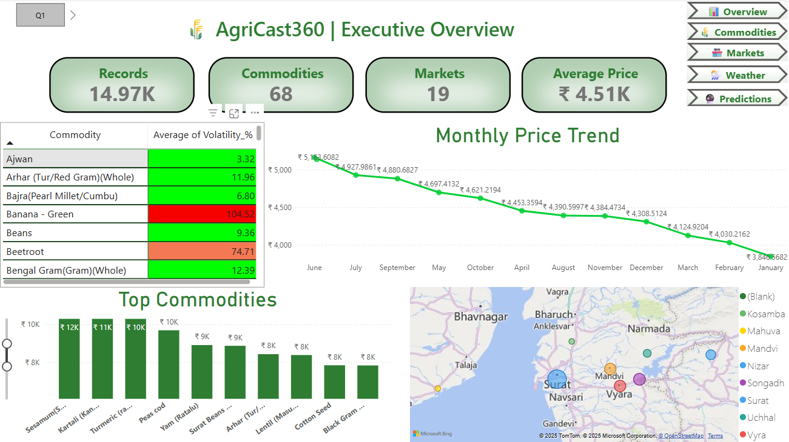
📊 Page 1: Executive Overview

I created this first page as a high-level summary for stakeholders. It's designed for an at-a-glance understanding of the overall market health.
- Key Performance Indicators (KPIs): I'm tracking the main metrics right at the top:
  - Records: 14.97K 📝
  - Commodities: 68 🌽
  - Markets: 19 📍
  - Average Price: ₹4.51K 💰
- Key Insights I've Visualized:
  - 📉 Monthly Price Trend: I used a line chart to show a clear downward price trend from a peak of ₹5,102 in June to ₹3,840 in January.
  - 📈 Volatility: I built a table to highlight commodity volatility. You can immediately see that Banana - Green is extremely volatile (104.94%), while Ajwan is very stable (3.92%).
  - 🏆 Top Commodities: This bar chart ranks the top commodities. In my current view, Sesamum (Sesame), Kartali (Bitter Gourd), and Turmeric are leading.
  - 🗺️ Geographic View: I embedded a map to visualize all 19 markets, which you can see are concentrated in the Gujarat region (e.g., Surat, Vyara, Mandvi).

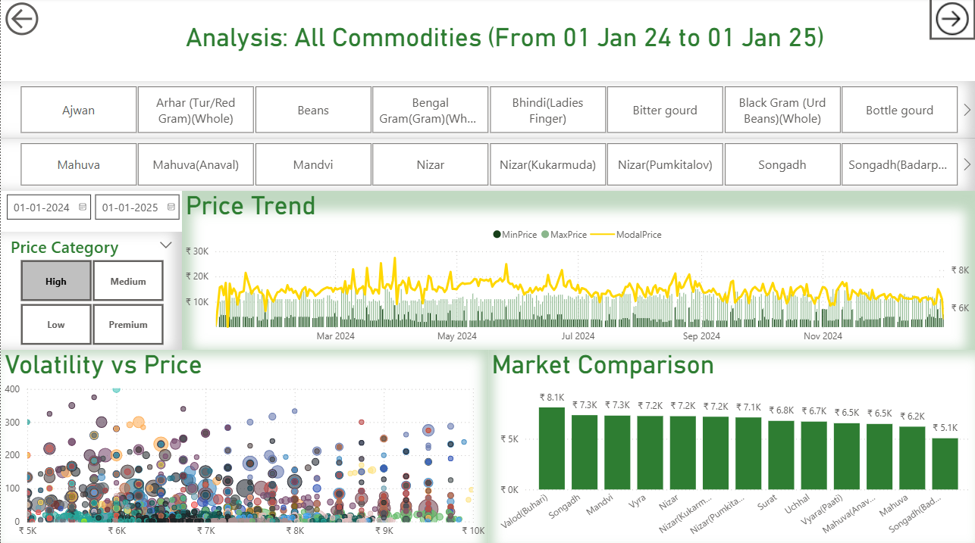
🌾 Page 2: Commodity Analysis

I designed this page to allow users to deep-dive into the price trends and volatility of specific commodities.
- Filters: I've added filters so you can drill down by Commodity, Market, Date Range, and even a custom Price Category (High, Medium, Low, Premium).
- Key Insights I've Visualized:
  - Price Trend (Jan '24 - Jan '25): I used a combo chart to track the MinPrice (bars), MaxPrice (yellow line), and ModelPrice (grey line) over the year. This shows the daily fluctuations.
  - Volatility vs. Price: This scatter plot visualizes the relationship between price and volatility. I used bubble size to represent trading volume, which helps identify commodities that are both expensive and high-risk.
  - Market Comparison: This bar chart ranks the top markets for whatever commodity you select. Here, Valod(Buhari), Songadh, and Mandvi are the top three.

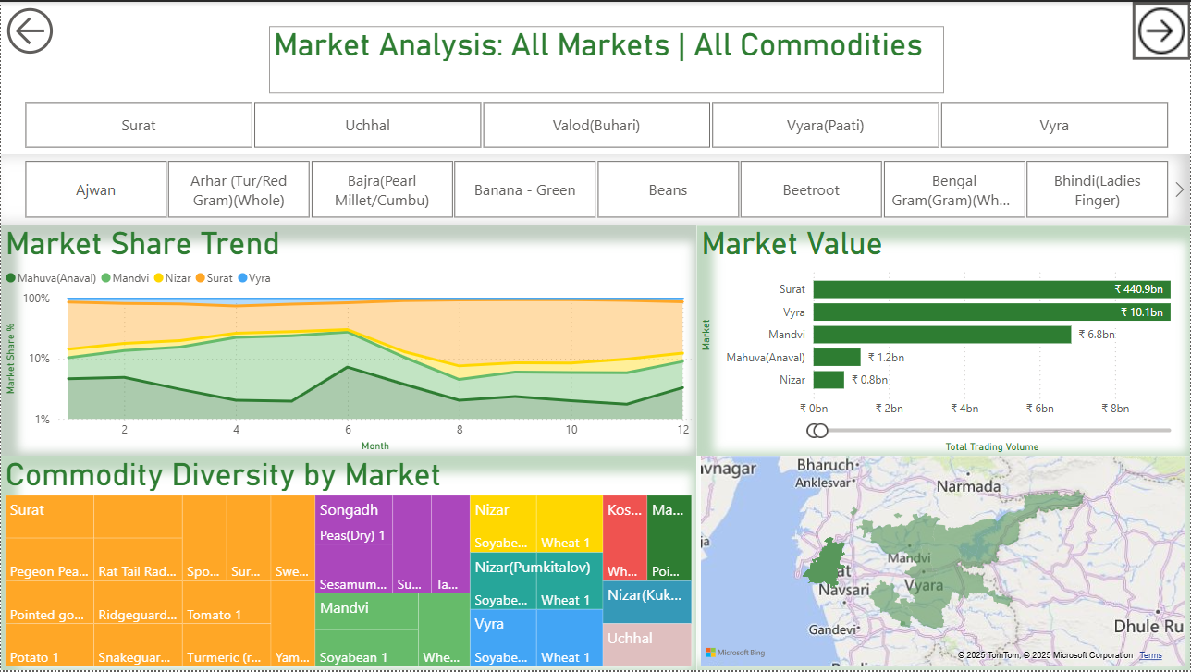
📍 Page 3: Market Intelligence

My Market Intelligence page focuses on comparing the performance, share, and diversity of the 19 different markets.
- Filters: I've included filters for both Market and Commodity.
- Key Insights I've Visualized:
  - Market Value: I used a bar chart to make the dominant market obvious. As you can see, Surat is the leader by a massive margin, valued at ₹440.9 billion.
  - Market Share Trend: I built a 100% stacked area chart to show how the market share for key markets (Mahuva, Mandvi, Nizar, Surat, Vyra) has shifted over 12 months.
  - Commodity Diversity by Market: I used a treemap to break down which commodities are most prevalent in each market, helping to understand market specialization.

☀️ Page 4: Weather Impact
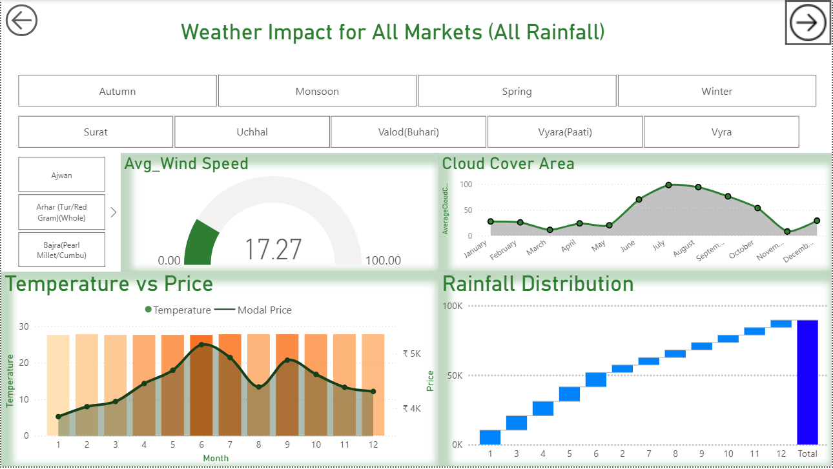
This is one of my favorite pages. Here, I've built a powerful analysis that directly correlates environmental factors with agricultural market prices.
- Filters: I enabled analysis by Season, Market, and Commodity.
- Key Insights I've Visualized:
  - 🌡️ Temperature vs. Price: I created a combo chart that overlays monthly temperature (bars) with the modal price (line). This clearly shows a correlation: price peaks in May-June, at the same time as the temperature peaks.
  - Weather KPIs: I'm also tracking key metrics like Avg. Wind Speed (17.27 💨) and Cloud Cover Area (☁️).
  - 🌧️ Rainfall Distribution: I used a waterfall chart to show the cumulative monthly rainfall, which provides important context for crop cycles.

📈 Page 5: Predictive Analytics

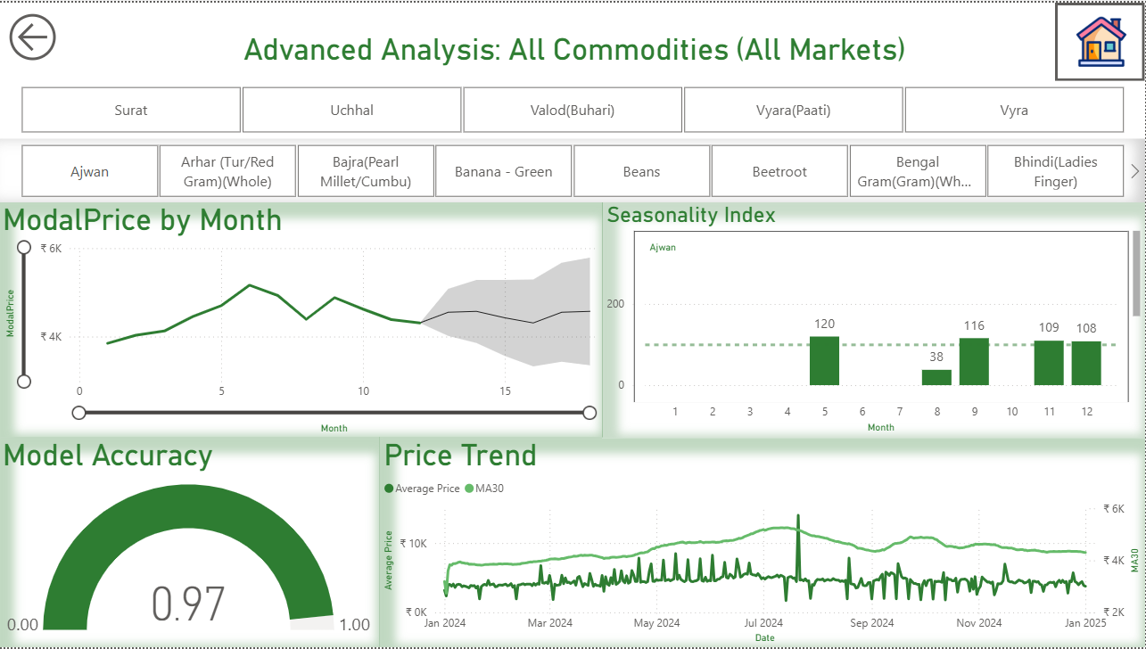
On my final page, I used historical data to forecast future trends and identify seasonal patterns.
- Filters: You can generate predictions for specific commodities and markets.
- Key Insights I've Visualized:
  - Model Accuracy: The predictive model I've implemented has a very high accuracy score of 0.97 (or 97%) ✅.
  - Price Forecast: My ModalPrice by Month chart shows the historical price (solid line) and projects it into the future, providing a forecasted range (shaded area) to help with decision-making.
  - Seasonality Index: This bar chart I created identifies seasonal behavior. For Ajwan, it shows strong seasonal peaks in May (120) and September (116). This tells you the best and worst months to sell.
  - Moving Average: This Price Trend chart compares the daily Average Price with its 30-day moving average (MA30) to smooth out volatility and identify long-term trends.

❓ Dashboard Q&A

- Which commodity is the most volatile?
  - Answer: Lemon, Onion and Turmeric (raw), with an average volatility of 226.36%, 224.59%, 223.57% accordingly.
- Which market is the most valuable?
  - Answer: Surat, with a total market value of ₹440.9 billion.
- What is the overall price trend for commodities over the past year?
  - Answer: I show a general downward trend, with prices peaking in June at ₹5,102 and falling to ₹3,840 by January.
- How accurate is my price prediction model?
  - Answer: It is 97% accurate.
- Does weather affect commodity prices?
  - Answer: Yes. My 'Temperature vs Price' chart shows a clear correlation where modal prices peak in May and June, the same months that temperatures are highest.
- For the commodity Ajwan, when is the price seasonally highest?
  - Answer: My Seasonality Index shows prices for Ajwan peak in May (index 120) and September (index 116).
- Does rainfall affect commodity prices?
  - Answer: Yes, it provides critical context. My 'Rainfall Distribution' chart shows rain accumulates heavily from June through September (the monsoon season). This period aligns with the peak in prices and the peak in cloud cover, suggesting that the entire monsoon season (rain, cloud cover, and high temperatures) collectively has a significant impact on prices.
- Which are the top 3 most traded commodities?
  - Answer: Sesamum (Sesame), Kartali (Bitter Gourd), and Turmeric.
- When does cloud cover (and likely, rainfall) peak during the year?
  - Answer: It peaks between June and September, consistent with the monsoon season.
- What does the 'Market Share Trend' chart on my Market Intelligence page show?
  - Answer: It visualizes the changing dominance (as a percentage of 100%) of the key markets (Mahuva, Mandvi, Nizar, Surat, etc.) relative to each other over 12 months.

